**EXPRIMENT NO-12**

**CSA1142-OBJECT ORIENTED ANALYSIS AND DESIGN**

**FOREGIN TRADING SYSTEM**

**USE CASE**

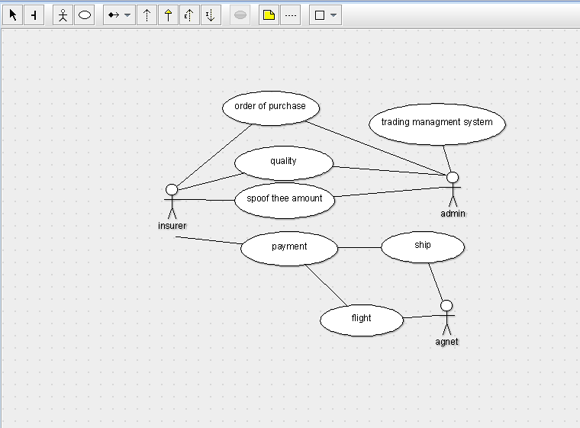

STATE DIAGRAM

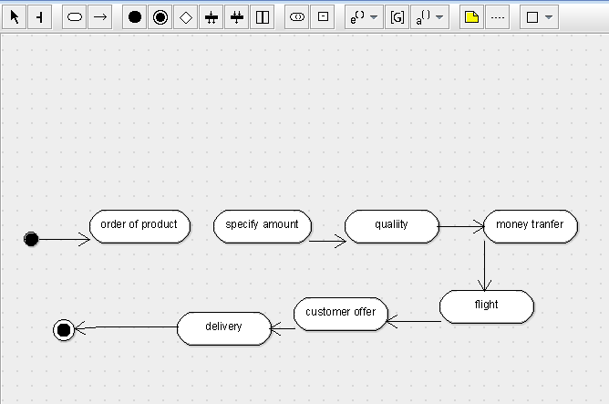

SEQUENCE DIAGRAM

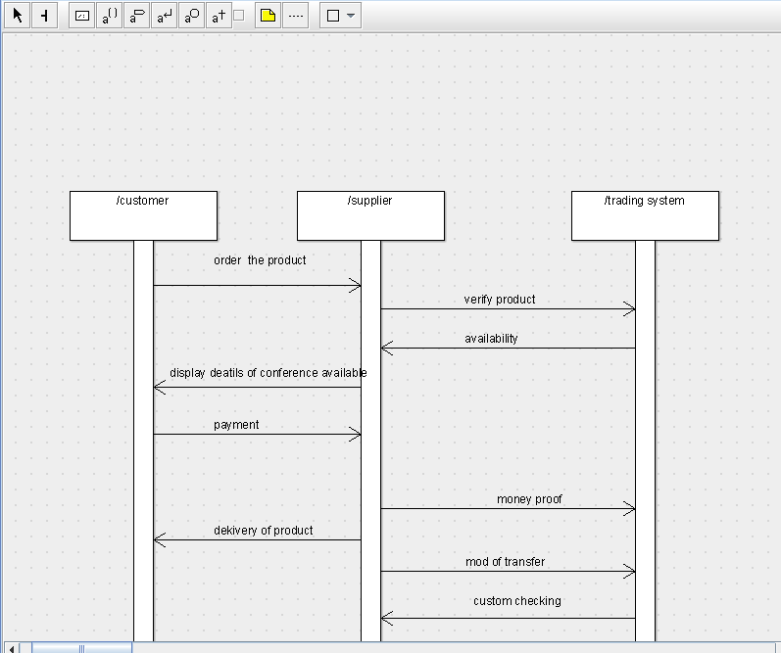

DEPLOYMENT DIAGRAM

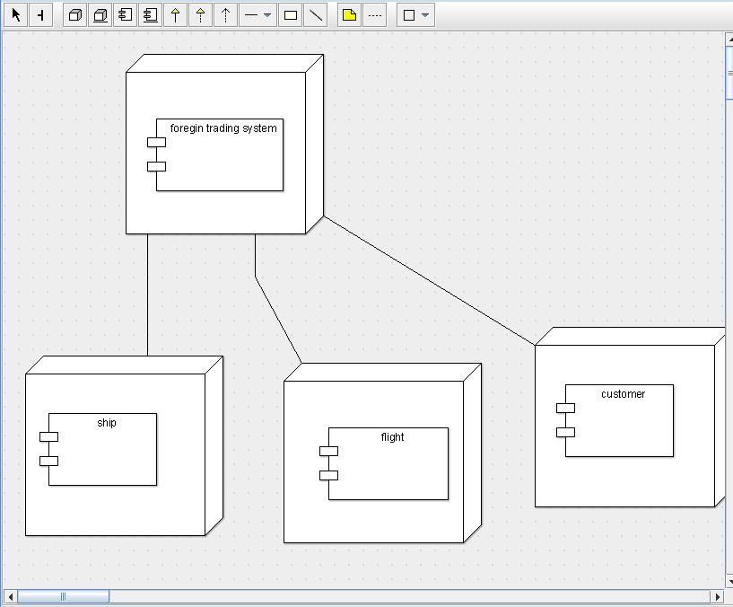

COMPONENT DIAGRAM

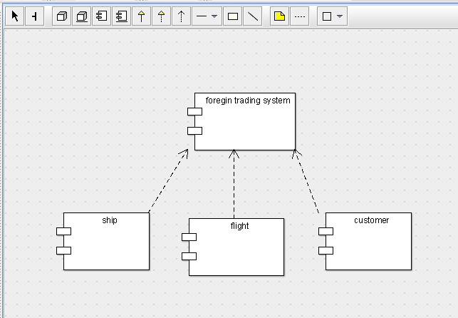

COLLABORATION DIAGRAM

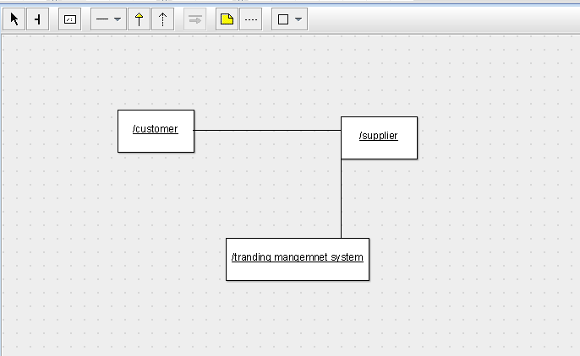

CLASS DIAGRAM

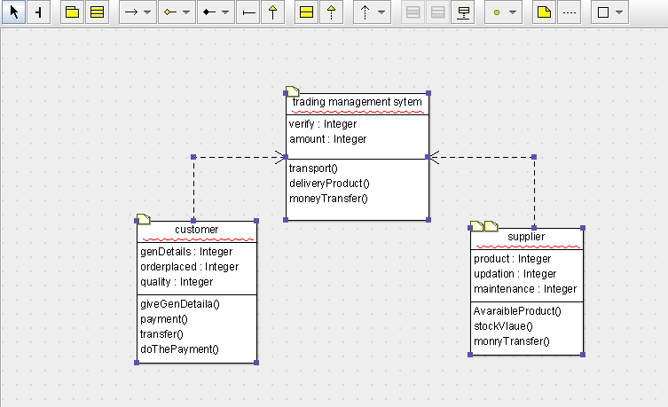

ACTIVITY DIAGRAM

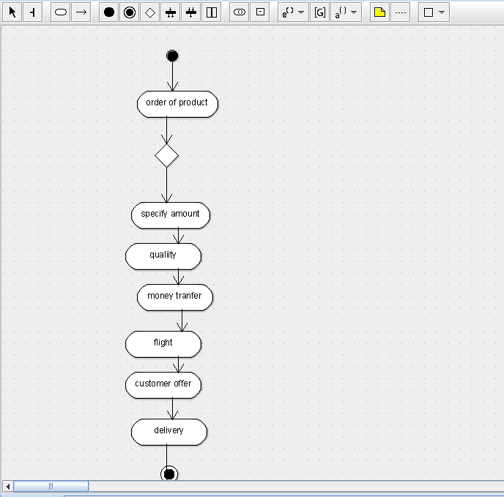

SKELETON CODE;

public class trading management sytem {

  public Integer verify;

  public Integer amount;

  public void transport() {

  }

  public void deliveryProduct() {

  }

  public void moneyTransfer() {

  }

}

public class supplier {

  public Integer product;

  public Integer updation;

  public Integer maintenance;

  public void AvaraibleProduct() {

  }

  public void stockVlaue() {

  }

  public void monryTransfer() {

  }

}

public class customer {

  public Integer genDetails;

  public Integer orderplaced;

  public Integer quality;

  public void giveGenDetaila() {

  }

  public void payment() {

  }

  public void transfer() {

  }

  public void doThePayment() {

  }

}